Opportunity > End of Month (JS Button)

UI

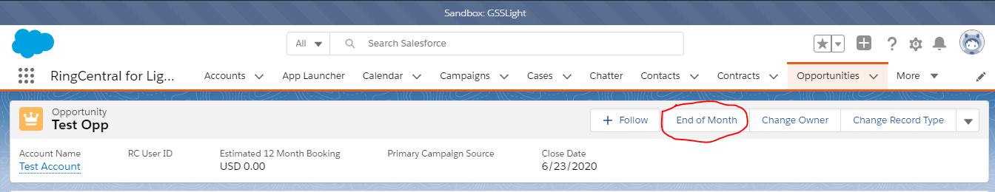

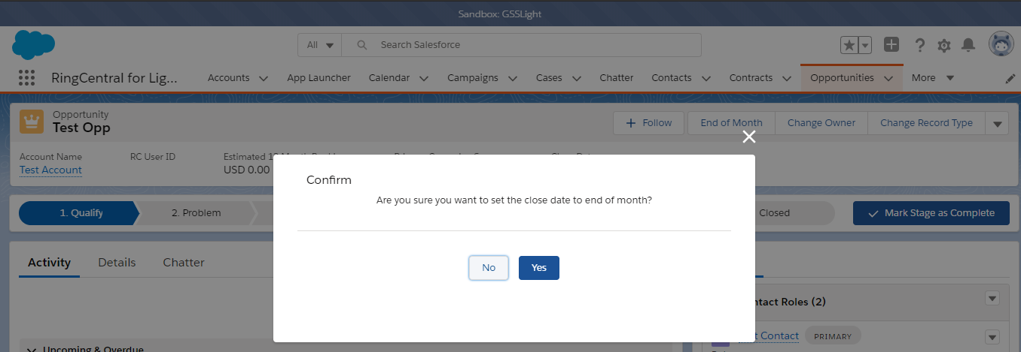

Component :

1. OpportunityLightningController (Class)
2. opportunityEndOfMonth (Lightning Component-Aura)